Technical / Operational Paperwork:

**Technical & Operational Implementation Plan  
Prepared For:** Internal Data/IT Teams, Consultants & Implementation Partners  
**Date:** July 4, 2025

**1. Technical Architecture Overview**

**1.1 System Architecture Philosophy**

This platform is built on a cloud-native, microservices architecture emphasizing scalability, security, and maintainability. It adheres to industry best practices, including event-driven processing, API-first design, and zero-trust security principles.

[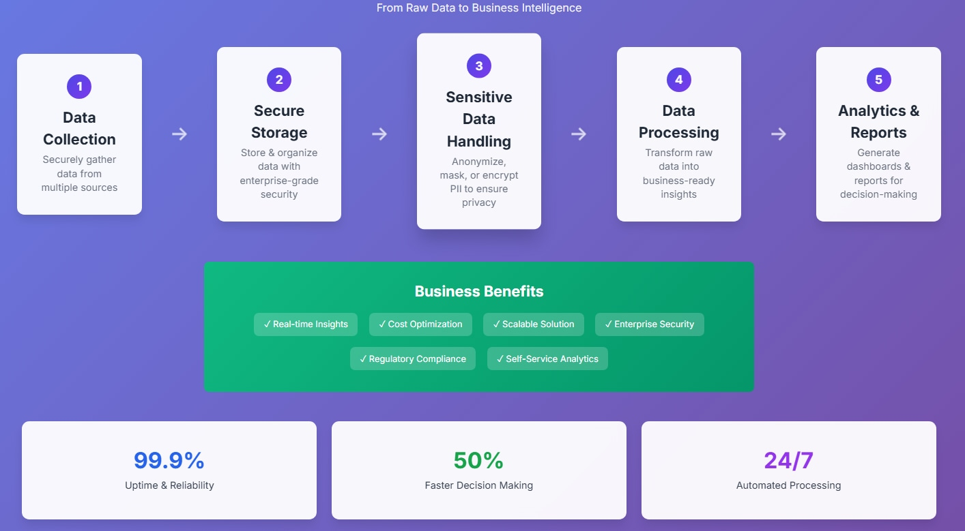](https://camo.githubusercontent.com/09f7b5f46aad7bc6add1bf547f593f7be490ce1db3992e3bb6f13750b775b261/68747470733a2f2f666173742e696d6167652e64656c69766572792f736b7365626d6a2e706e67)

**1.2 Core Architecture Components**

* **Data Ingestion Layer:** Multi-protocol ingestion (SFTP, HTTPS, API, DB), real-time/batch processing, validation, error handling, metadata extraction.
* **Data Processing Layer:** ETL pipelines, data cleansing, normalization, business rule application, quality monitoring.
* **Data Storage Layer:** Raw data lake (S3), structured data warehouse (Redshift), operational data store (DynamoDB), metadata repository.
* **Analytics Layer:** Statistical analysis, machine learning, AI, geospatial analysis, time-series forecasting.
* **Presentation Layer:** Interactive dashboards (Power BI Pro), mobile/web interfaces, API endpoints, automated report generation.

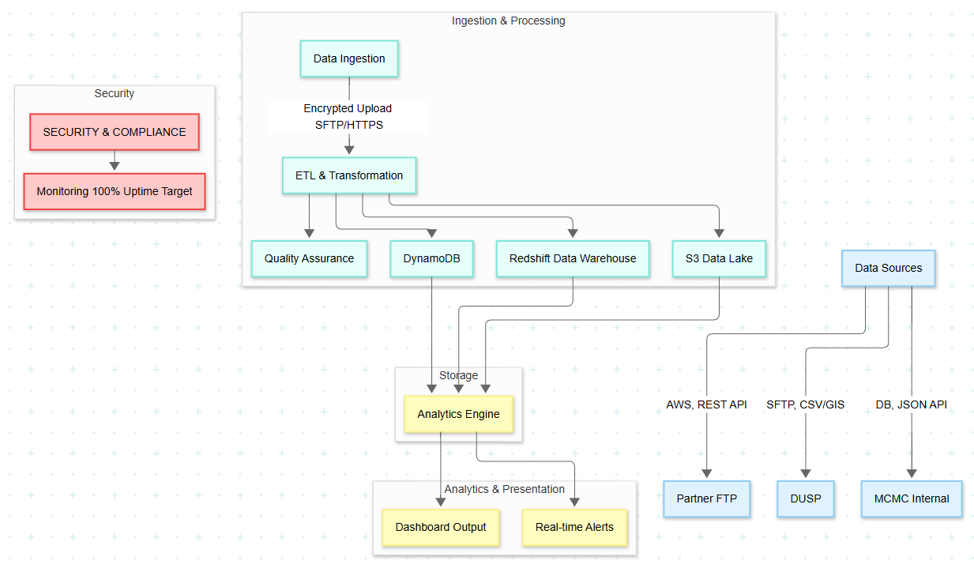

**Architecture & Operational Flow**

[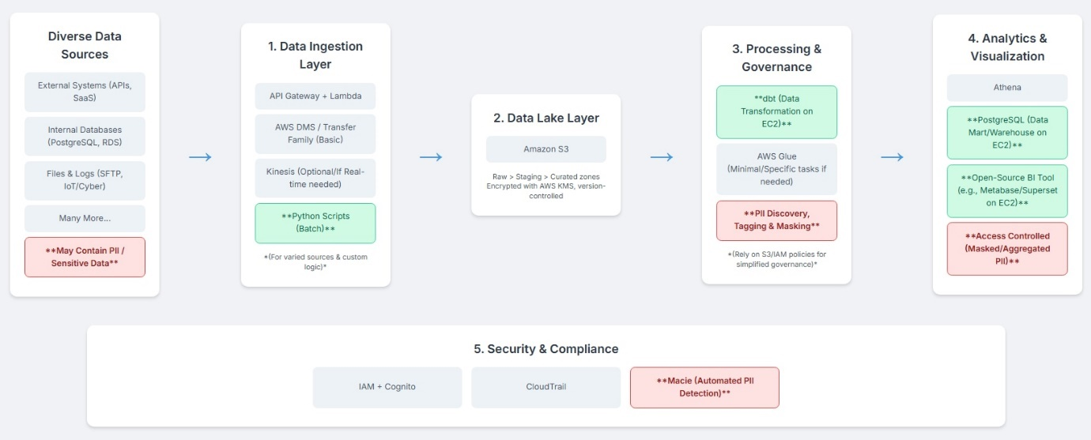](https://camo.githubusercontent.com/1699b2fbd80ed3ca9e387cb7863dbb242c09ca85c24e2367fb486179a0b5586d/68747470733a2f2f666173742e696d6167652e64656c69766572792f63686b6c7072652e706e67)

**1.3 Core System Components**

**1. Data Ingestion Layer**

* **Multi-Protocol Support**: SFTP, HTTPS, API, Database connections
* **Processing Modes**: Real-time streaming and batch processing
* **Data Validation**: Schema validation, quality assurance, error handling
* **Volume Capacity**: 1-2 million data points daily

**2. Data Processing Engine**

* **ETL Pipelines**: Extract, Transform, Load with automated workflows
* **Data Quality**: Cleansing, normalization, business rule application
* **Technologies**: AWS Glue, Step Functions, Apache Spark
* **Monitoring**: Real-time job tracking and alerting

**3. Storage Architecture**

* **Data Lake**: Raw data storage in Amazon S3
* **Data Warehouse**: Structured analytics in Amazon Redshift
* **Operational Store**: Real-time processing with DynamoDB
* **Security**: AES-256 encryption at rest and TLS 1.3 in transit

**4. Analytics & Visualization**

* **Primary Platform**: Microsoft Power BI Pro
* **Advanced Analytics**: R/Python for statistical analysis
* **Machine Learning**: AWS SageMaker for predictive models
* **Mobile Access**: Responsive dashboards for executive use

**2.0 Detailed Data Flow Architecture**

**Data Sources Integration:**

*DUSP (Department of Urban and Spatial Planning) Integration:*

* Connection Type: Secure SFTP with certificate-based authentication
* Data Format: CSV, Excel, Geospatial files (SHP, KML)
* Transfer Schedule: Daily batch uploads at 2:00 AM
* Data Volume: 50,000-100,000 records per day
* Validation: Schema validation, data type checking, completeness verification

*Internal Systems Integration:*

* Connection Type: Database direct connection (encrypted)
* Data Format: Structured database tables, JSON APIs
* Transfer Schedule: Real-time streaming with 15-minute batch processing
* Data Volume: 200,000-500,000 records per day
* Validation: Business rule validation, referential integrity checks

*Technology Partner Integration:*

* Connection Type: RESTful APIs with OAuth 2.0 authentication
* Data Format: JSON, XML, structured data feeds
* Transfer Schedule: Hourly updates with real-time alerts
* Data Volume: 100,000-200,000 records per day
* Validation: API response validation, data freshness checks

**Data Processing Pipeline:**

*Stage 1: Raw Data Ingestion*

* Automated file detection and processing
* Data format identification and parsing into parquet format.
* Initial data quality assessment
* Metadata extraction and cataloguing

*Stage 2: Data Transformation*

* Data cleansing and standardization
* Business rule application
* Data enrichment and augmentation
* Master data management and deduplication

*Stage 3: Data Loading*

* Structured data warehouse population
* Data mart creation for specific use cases
* Index creation and optimization
* Data partitioning and archiving

*Stage 4: Quality Assurance*

* Data quality monitoring and reporting
* Exception handling and notification
* Data lineage tracking
* Audit trail generation

**3. Technology Stack Specification**

**3.1 Cloud Infrastructure (Amazon Web Services)**

* **Compute**: EC2, Auto Scaling Groups, Elastic Load Balancing, AWS Lambda.
* **Storage**: S3 (data lake), EBS (database), Glacier (archival), EFS (shared files).
* **Database**: Amazon Redshift (data warehousing), RDS (PostgreSQL, MySQL), DynamoDB (NoSQL), ElastiCache (caching).
* **Analytics**: AWS Glue (ETL), Step Functions (workflow), SageMaker (ML), QuickSight (visualization).
* **Security**: IAM, VPC, WAF, GuardDuty.

**3.2 Application Stack**

* **Data Integration:** Apache Kafka (streaming), Apache Airflow (orchestration), Talend, Custom Python/Java.
* **Analytics Platform:** Microsoft Power BI Pro (primary visualization), R/Python (statistical analysis), Apache Spark (big data), TensorFlow/PyTorch (ML).
* **Monitoring & Operations:** AWS CloudWatch, Elasticsearch/Kibana, Grafana, PagerDuty.

**4. Security Architecture & Compliance**

**4.1 Security Framework**

* **Network Security:** VPC, VPN, Network ACLs, AWS Shield (DDoS).
* **Data Security:** Encryption at rest (AES-256), encryption in transit (TLS 1.3), AWS KMS, database/column-level encryption.
* **Identity and Access Management:** MFA, RBAC, least privilege, regular access reviews.
* **Compliance and Governance:** PDPA compliance, data classification, audit logging, regular security assessments.

**4.2 Data Privacy Implementation**

* **PII Protection:** Data masking/tokenization, secure transmission, access logging, retention/purging policies.
* **Consent Management:** Consent tracking, data subject rights, privacy impact assessments, regular compliance audits.

**5. Operational Procedures & Workflows**

**5.1 Month 1-3 Operations (MVP Phase)**

* **Week 1-2:** Infrastructure setup (AWS account, VPC, EC2, DB).
* **Week 3-4:** Data pipeline development (ETL, source connectivity, initial ingestion, basic dashboard).
* **Week 5-6:** Integration testing (end-to-end, performance, security, UAT).
* **Week 7-8:** Deployment and training (production deployment, user training, go-live support, initial optimization).

**5.2 Month 4-7 Operations (Advanced Analytics Phase)**

* Advanced analytics development (statistical models, ML pipelines, GIS integration, enhanced dashboards).
* System scaling (performance monitoring, capacity planning, security enhancements, additional data sources).

**5.3 Month 8-12 Operations (Predictive Analytics Phase)**

* Predictive model development (ML model training, real-time prediction, deployment, monitoring).
* Advanced features implementation (real-time alerts, advanced visualization, mobile app, external system integration).

**6. Monitoring & Alerting Framework**

**6.1 System Health Monitoring**

* **Infrastructure:** CPU, memory, disk, network performance, database performance, APM.
* **Application:** ETL job success/failure, data quality metrics, dashboard performance, user activity.
* **Security:** Failed logins, unusual access patterns, data access auditing, incident response.

**6.2 Alerting Configuration**

* **Critical Alerts (Immediate):** System downtime, data breach, critical ETL failures, DB connectivity.
* **Warning Alerts (4-hour Response):** Performance degradation, data quality issues, high resource utilization.
* **Informational Alerts (24-hour Response):** Scheduled maintenance, capacity planning, backup completion.

**7. Backup & Disaster Recovery**

**7.1 Backup Strategy**

* **Data Backup:** Daily automated DB backups, continuous S3 backup (versioning), weekly full system, monthly Glacier archival.
* **Configuration Backup:** Infrastructure as Code (IaC) templates, application/security configuration, documentation.

**7.2 Disaster Recovery Planning**

* **Recovery Time Objectives (RTO):** Critical (4 hours), Important (24 hours), Non-critical (72 hours).
* **Recovery Point Objectives (RPO**): Critical (1 hour), Important (4 hours), Non-critical (24 hours).
* **Procedures:** Multi-AZ deployment, cross-region backup, automated failover, regular testing.

**8. Performance Optimization**

* **Database Optimization:** Query optimization, indexing, partitioning, connection pooling, caching.
* **Application Optimization:** Code optimization, caching, load balancing, scaling, profiling.
* **Infrastructure Optimization:** Resource right-sizing, auto-scaling, network optimization, cost optimization.

**9. Resource Planning & Budget Allocation**

**9.1 Human Resources (FTE)**

* **Phase 1 (Months 1-3):** Lead Data Scientist (1), Data Engineer (0.5), DevOps Engineer (0.5), Project Manager (0.25).
* **Phase 2 (Months 4-7):** Lead Data Scientist (1), Data Engineers (2), Business Analyst (1), QA Engineer (0.5).
* **Phase 3 (Months 8-12):** Lead Data Scientist (1), Data Engineers (2), ML Engineer (1), UI/UX Designer (0.5).

**10. Ambiguous Study from Sample Data**

**10.1 Data Flow and Tabulation**

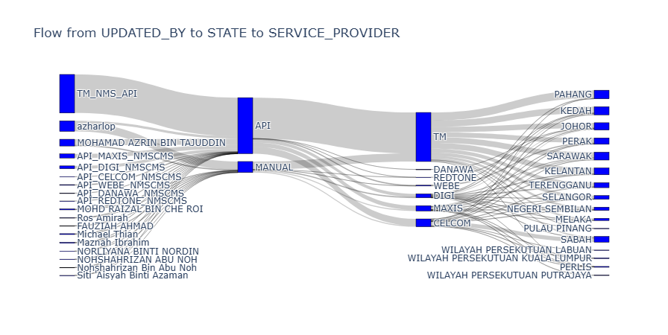  
*From data source to descriptive statistics*

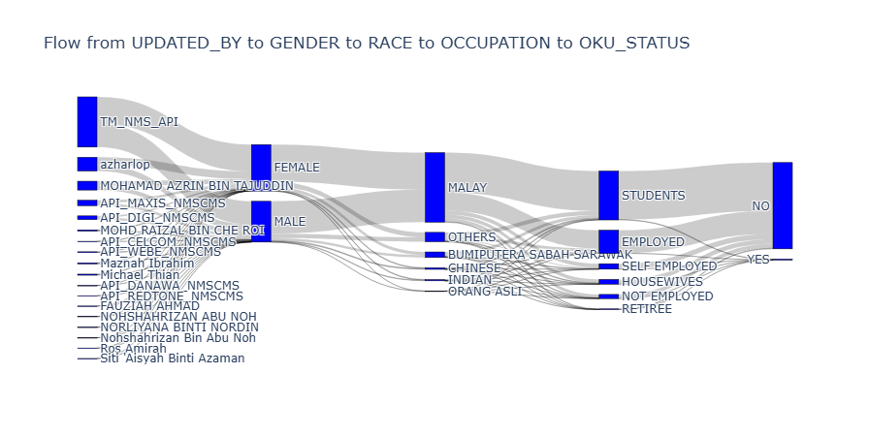

**10.2 Sample Data Visualization**

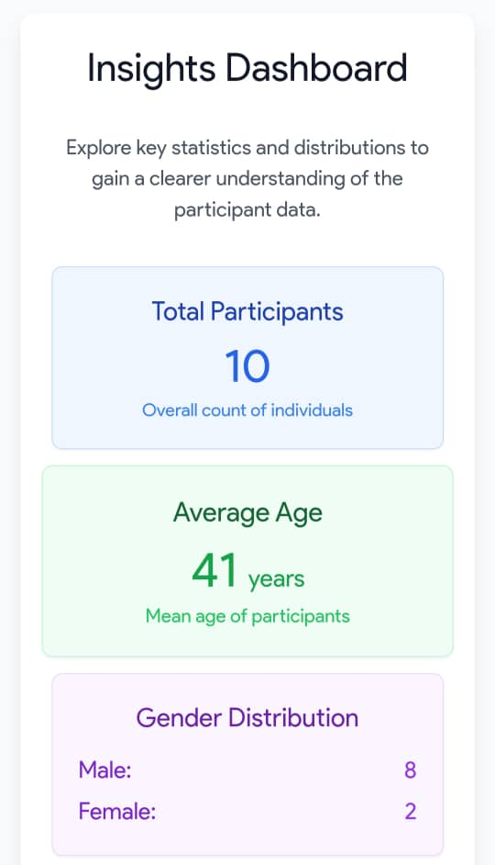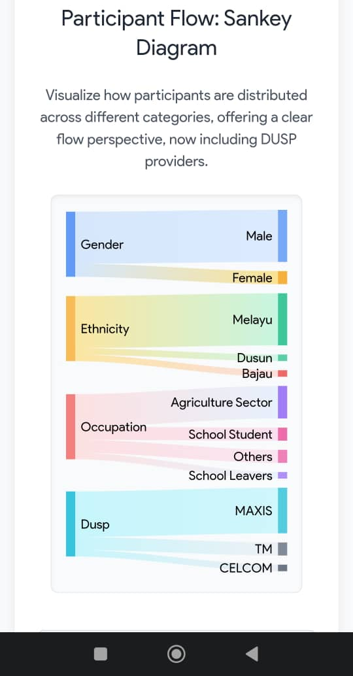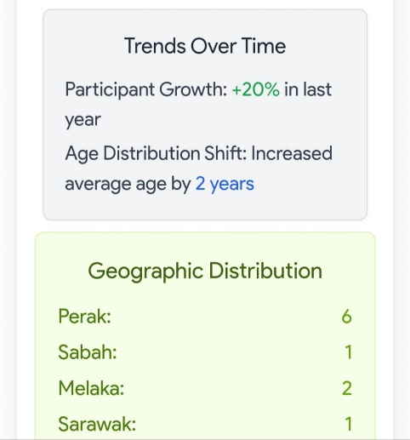 **Mapping visualization  
